Process and Procedure Names:  - Process: IT Management Operating System  - Procedure: HUE within IT Waterfall/Agile Projects | Work Instruction Name:  Prototyping | Effective Date: 20-Mar-2017
Work Instruction Owner:  Madhumita Gupta | Work Instruction Name:  Prototyping | Revision Date: 01-Nov-2017

Purpose

The purpose of prototyping is to show a draft version of the product, allowing users to explore intent behind a feature or the overall design before it is developed. Prototypes are meant to be easy to make and hence can easily be discarded or altered based on feedback. HUE training is a prerequisite: Prototyping training.

Scope

This work instruction is to create prototypes of websites/applications/services based on the wireframes created at the concept ideation stage.

.

Work Instruction Activities

Step # | Description | Owner (Role) | Details (e.g. screenshots, charts, etc.)
 | Use a prototyping tool like Axure/Marvel to display how different interactive elements will behave on user interaction. Prototypes at an early stage can connect wireframes to test with users in usability testing or heuristic evaluation.  If concepts or wireframes have already been created, use them as a basi for your prototypes. | HUE Representative | Applicable work instruction:  “Concept Ideation”
2 | In case of service design, create high fidelity service blueprint which expands the to-be experience diagram with additional information on service owner activity, internal processes and external processes. | HUE Representative
 | A low fidelity prototype helps you to gather feedback from stakeholders and end users early in the design process, make changes quickly, and improve your initial designs. | HUE Representative | Refer to Work Instruction  - “Usability Testing”
 | For an offering with UI use finalized designs with DLS (Design Language System) treatment applied visually to create high fidelity prototypes. | HUE Representative | Refer to DLS Portal  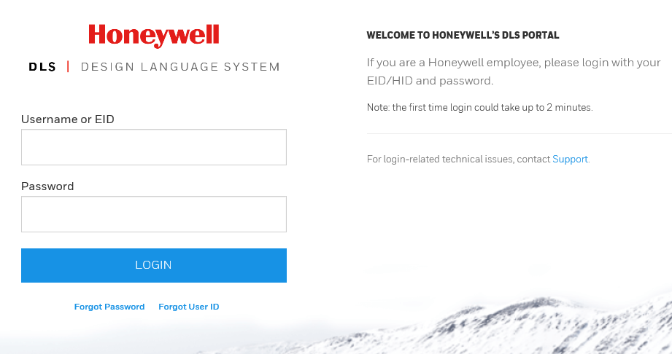
4 | Use this to get final stakeholder approval and end user feedback and communication to developers to convey design thought process. | HUE Representative
5. | Store prototype as project artefact on a shared location. | HUE Representative

Enforcement

Failure to adhere to published policies, processes, procedures, work instructions and standards will be evaluated on a case by case basis and may result in disciplinary action. Published policies, processes, procedures, work instructions and standards are also subject to audit by Honeywell Corporate Audit and external auditors for verification of compliance.

Version Control and Review Frequency

This Procedure is to be reviewed at minimum annually.

Date Last Reviewed: 08-Dec-2017
Reviewed By: Tobias Komischke, IT HUE Leader

Version # | Effective Date | Section(s) | Description | Author | Content/SME  Approval | Work Instruction Owner Approval
1.0 | 20-Mar-2017 | Full document | First version | Madhumita Gupta | Tobias Komischke | Tobias Komischke
2.0 | 01-Nov-2017 | All | Incorporated new role of HUE representative and aligned to approved HUE process integration with waterfall/agile Software process. Added service design work instruction steps | Madhumita Gupta | Tobias Komischke | Tobias Komischke
2.1 | 08-Dec-2017 | All | Formatting edits based on Process Change Register requests | Tobias Komischke | Madhumita Gupta | Tobias Komischke
*Process Owner, Process Governance and External Compliance approvals are through the automated tool

